What is Model Context Protocol?
What is a REST API?
FastMCP Server?
FastMCP Client?
MCP Protocol Methods?
MCP Tools?
MCP Resources?
MCP Prompts?
JSON-RPC — The Language of MCP?
MCP Sampling ?
MCP Transports?
SSE (Server-Sent Events)?

What is Model Context Protocol?

A protocol that allows AI models to securely connect to external tools, data sources, and systems.

Model Context Protocol (MCP) ek standard hai jo AI models (jaise LLMs) ko external tools, APIs, databases aur systems ke saath connect karta hai — smart tareeke se
MCP = AI ka “waiter” jo kitchen (tools/APIs) aur customer (AI model) ke beech communication manage karta hai.

Why we use MCP?
Without MCP:
- AI sirf apni training tak limited hota hai
- Real-time data access nahi hota
- Tools use karna mushkil hota
With MCP:
- AI real-time data le sakta hai 📡
- APIs call kar sakta hai 🔗
- Tools use kar sakta hai ⚙️
- Smart decisions le sakta hai 🧠

How we use MCP?

MCP ka flow kuch is tarah hota hai:
Steps:
- User question deta hai
- AI samajhta hai ke kya chahiye
- MCP Client request bhejta hai
- MCP Server decide karta hai kaunsa tool use hoga
- Tool/API se data aata hai
- AI response bana ke user ko deta hai

Why MCP is Important in AI?

Har tool ke liye alag integration nahi karna padta
AI ko relevant context milta hai
AI khud tools use karta hai (agent behavior)
Chatbots, AI employees, Automation systems, RAG (Retrieval Augmented Generation)

Biryani Style Example

Socho tum ek biryani restaurant chala rahe ho 😄
👨‍🍳 Components Mapping:
- Customer → User
- Waiter → MCP
- Chef → AI Model
- Kitchen tools → APIs / Database
Customer kehta hai:
👉 “Mujhe spicy chicken biryani chahiye”
Without MCP ❌
Chef confuse ho jata hai:
- Spice kitna? 🌶️
- Rice available hai ya nahi? 🍚
- Chicken fresh hai ya nahi? 🐔
👉 Result: ya toh galat order ya delay
With MCP ✅
- Waiter (MCP) order leta hai
- Kitchen se check karta hai:
  - Chicken available? ✔️
  - Rice ready? ✔️
  - Spice level? ✔️
- Chef ko proper context deta hai
- Chef perfect biryani banata hai 🍛🔥
👉 Result: perfect response

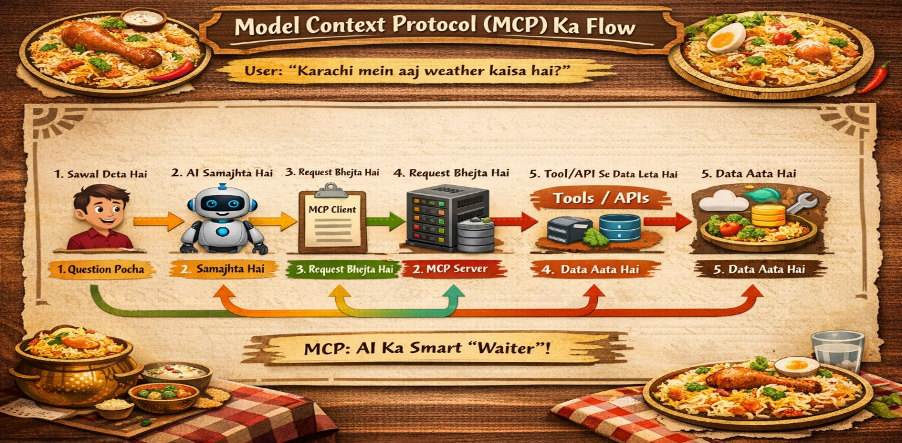
What is a REST API?
A REST API is a way for two computer systems to communicate over the internet using standard HTTP methods.

It allows applications (websites, mobile apps, servers, AI tools, etc.) to send requests and receive data from another system.

Think of a REST API as a waiter in a restaurant 🍽️:
- Client (You) → The person ordering food
- API (Waiter) → Takes the request to the kitchen
- Server (Kitchen) → Prepares the food
- Response (Food served) → The result returned to you

1️⃣ Endpoint
An endpoint is a URL where the API receives requests.
2️⃣ HTTP Methods (Actions)
REST APIs use standard HTTP methods:
Method | Purpose | Example
GET | Retrieve data | Get list of products
POST | Create new data | Add a new product
PUT | Update data | Update product details
DELETE | Remove data | Delete a product

3️⃣ Request
The client sends a request to the server

4️⃣ Response
The server sends data back, usually in JSON format.
{
"id": 10,
"name": "Laptop",
"price": 750,
"stock": 12
}

What FastMCP Server?

FastMCP Server is a lightweight Python framework used to quickly build an MCP server that allows AI models to connect with tools, resources, and external systems using the Model Context Protocol (MCP).

FastMCP is basically the server layer that exposes tools to AI.
# Install FastMCP
pip install fastmcp
fastmcp run main.py --transport sse --port 8000

Test with MCP Inspector
npx @modelcontextprotocol/inspector

Run the Client
python client.py

FastMCP Server aik special server hota hai jo AI models (jaise OpenAI ke models) ko external tools, APIs, databases ke sath connect karta hai through Model Context Protocol (MCP).

FastMCP Server = “AI ka waiter” jo AI ko tools serve karta hai.
Biryani Style Explanation
AI = Guest 🍽️
FastMCP Server = Waiter 👨‍🍳
Tools/APIs = Biryani ke dishes 🍗🍚
Guest (AI) bolta hai:
👉 “Mujhe user ka data chahiye”
Waiter (FastMCP Server) kya karta hai?
👉 Kitchen (API/DB) se data laata hai
👉 Plate mein serve karta hai
🔥 AI ko khud kitchen mein nahi jana parta!

FastMCP Server kyun use karte hain?
AI directly APIs call nahi karta — FastMCP Server karta hai.
API keys server mein safe rehti hain (AI ko direct access nahi milta).
MCP protocol use hota hai → clean, standard communication.
AI ko powerful banane ke liye database read, APIs call, automation.
FastMCP Server kaise use karte hain?
Step-by-step flow:
- AI Agent request bhejta hai
- MCP Client request forward karta hai
- FastMCP Server receive karta hai
- Server tool/API call karta hai
- Response AI ko wapas deta hai
Karachi Traffic Challan Check Example
User bolta hai:
“Mera challan check karo”
AI bolta hai: “Number plate KA1234 ka data lao”
FastMCP Server: “Traffic API call karta hai.”
API response: “Rs 2000 challan pending”
Server: AI ko deta hai:
AI: User ko bolta hai “Aapka challan Rs 2000 hai”
AI mein FastMCP Server important kyun hai?
Without FastMCP:
AI = sirf baatein karta hai (no real action)
With FastMCP:
AI = real duniya mein kaam karta hai

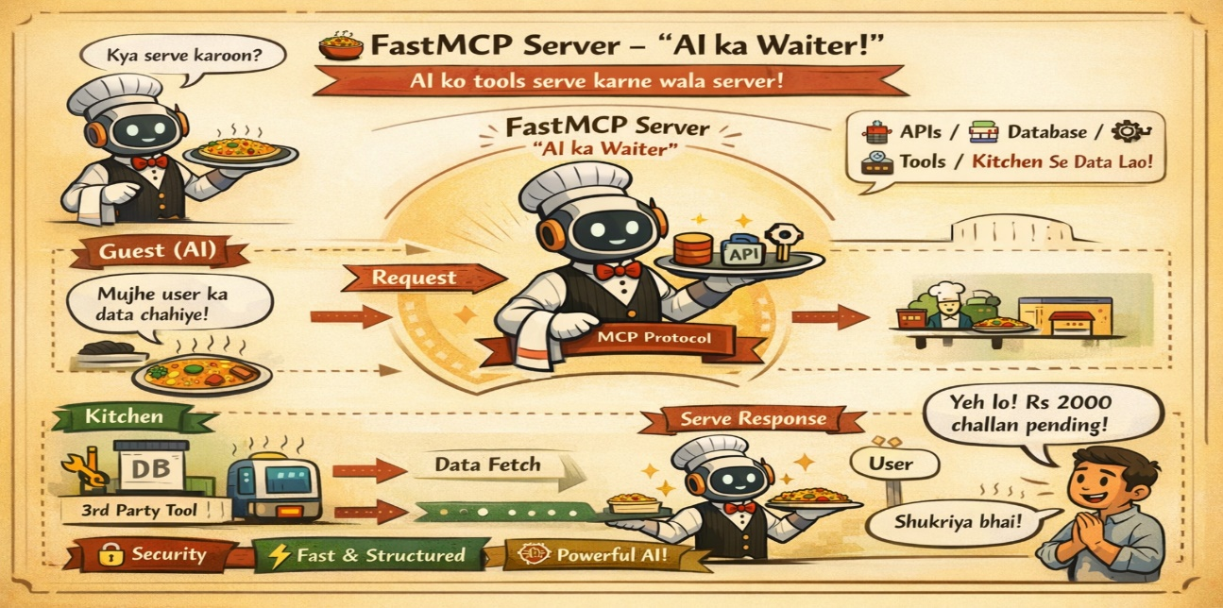
What is FastMCP Client?

Socho tum AI ka system bana rahe ho jahan AI agent ko bahar ke tools (APIs, DB, functions) se baat karni hai.
FastMCP Client wo “waiter” hai jo AI (customer) ki request ko uthata hai aur FastMCP Server (kitchen) tak pohanchata hai.

Simple line:
FastMCP Client = AI aur tools ke darmiyan communication bridge

Biryani Example (Zabardast Samajh)
- 👨‍🍳 Kitchen = FastMCP Server
- 🧑 Customer = AI Agent
- 🍽️ Waiter = FastMCP Client

Customer (AI) bolta hai:
👉 “Mujhe Chicken Biryani chahiye”
Waiter (Client):
👉 Order le kar kitchen (Server) ko deta hai
Kitchen:
👉 Biryani bana kar wapas deta hai
Waiter:
👉 Customer ko serve karta hai
💡 Yani Client ka kaam hai:
- Request lena
- Server ko bhejna
- Response wapas lana

FastMCP Client kyun use karte hain?
AI directly har API se baat nahi karta → Client beech mein handle karta hai

FastMCP optimized hota hai → low latency
Sab tools ek hi language mein baat karte hain (MCP protocol)
Client change karo → server ya tools change karne ki zarurat nahi

FastMCP Client kaise use karte hain?
AI Agent request banata hai
FastMCP Client us request ko MCP format mein convert karta hai
Server ko send karta hai
Server tool run karta hai
Response client ko milta hai
Client AI ko return karta hai

coding
from fastmcp import Client
client = Client("http://localhost:8000")
response = client.call_tool(
name="get_weather",
arguments={"city": "Karachi"})
print(response)

AI mein FastMCP Client important kyun hai?
AI sirf text nahi → real world actions kar sakta hai
New tools easily add ho jate hain
Multi-tools integration
Modern AI Agents (AutoGPT style) isi architecture pe depend karte hain

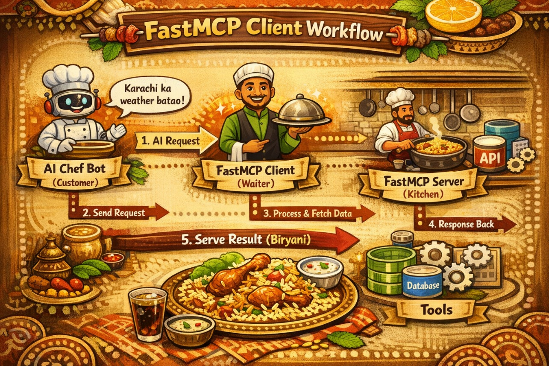

MCP Protocol Methods
MCP (Model Context Protocol) ke methods woh specific actions hain jo AI system use karta hai communication ke liye — jaise client aur server ke darmiyan “commands”.
Methods = woh tareeqay jin se AI baat karta hai, data mangta hai, aur kaam karta hai”
Biryani Style Samajh lo
Socho tum ek biryani restaurant chala rahe ho:
- 👨‍🍳 Server (Kitchen) = Tools / APIs
- 🧑‍💻 Client (Waiter) = AI Agent
- 🍽️ User (Customer) = Tum
Ab MCP Methods = Waiter ke actions
Important MCP Protocol Methods
1. initialize
System start karne ke liye
“Bhai waiter kitchen ko bol raha: boss ready ho jao, customer aa gaya hai!”
2. tools/list
Available tools ki list lena
“Waiter: aaj menu mein kya kya hai? Chicken biryani, beef biryani ya pulao?”
3. tools/call
“Customer ne bola: ek spicy chicken biryani lao 🔥
Waiter kitchen ko order deta hai → yehi tools/call hai”.
4. resources/list
Available data/resources dekhna
“Kitchen check: chawal hai? masalay hain? chicken fresh hai?
5. resources/read
Specific data read karna
“Recipe book kholo aur dekho chicken biryani ka exact formula kya hai”
6. completion / response
Final answer dena
Waiter garam garam biryani table pe serve karta hai
MCP Protocol Methods kyun use karte hain?
Method | What It Does
tools/list | Returns all registered tools with their names, descriptions, and input schemas
tools/call | Executes a specific tool by name with the given arguments and returns the result

MCP Tools (Model-Controlled Primitive)
Tools are executable functions exposed by an MCP server that allow AI models to perform actions such as creating, updating, or deleting data in external systems.
They follow a model-controlled paradigm — the AI model autonomously discovers available tools via tools/list and decides when to invoke them via tools/call.

MCP Resources (App-Controlled Primitive)
Resources are read-only data endpoints exposed by an MCP server, allowing AI models to access pre-authorized information such as documents, configurations, and reference data.
They follow an app-controlled paradigm — the host application decides which data to expose, and the model simply reads what is made available via resources/list and resources/read.

MCP Prompts (User-Controlled Primitive)
Prompts are pre-crafted instruction templates created by domain experts that encode specialized knowledge into reusable, discoverable workflows.
They follow a user-controlled paradigm — the user explicitly selects which prompt to apply (e.g., via slash commands like /contract_review), unlike tools where the model decides autonomously.

JSON-RPC — The Language of MCP?
What is JSON-RPC?
Think of your MCP Client as a person walking into a shop (MCP Server) to ask for something. The way they ask and receive — that specific language — is JSON-RPC.
1 Request
The client asks the server to do something
2 Response
The server replies back.
3 Error
If something goes wrong:
4 Notification (Bonus)
A notification has no id. The client just informs the server — no reply needed.
5 Simple Analogy
JSON-RPC | Real Life
Request | Placing a pizza order
id | Your order/token number
method | Which pizza you want
result | Pizza delivered
error | Pizza not available
notification | "I'm on my way" — no reply expected

MCP Sampling
In the normal flow:
Client → Server → Result
In sampling:
Server → Client → "Ask the LLM" → Server
The server wants to use an LLM itself — but it can't do it directly, so it asks the client!

MCP Transports
A transport is the method used to send messages between the Client and Server. Think of it as the road between two houses — the houses are the same, but the road can be different.

SSE (Server-Sent Events)
SSE means the server runs independently on a port (like a website) and clients connect to it over HTTP. The server stays alive and keeps an open connection so it can push messages back to the client in real-time.

